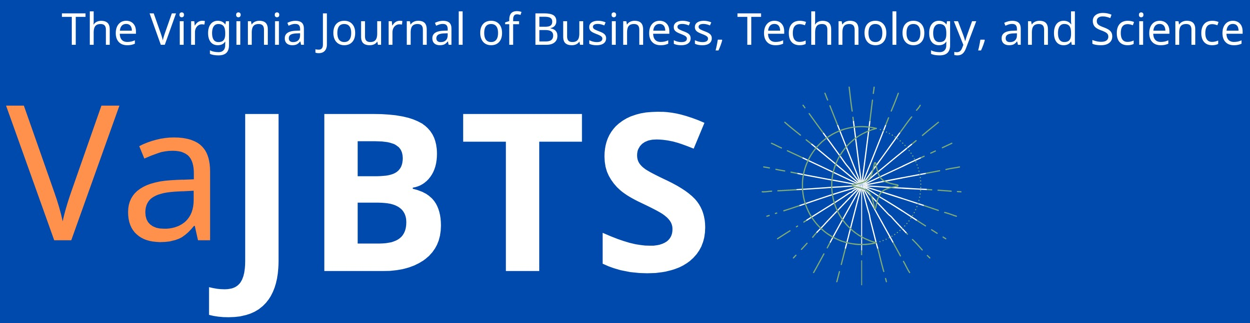
Facemask Wearing and Social Distancing: A Test of Risk Compensation Theory
Myriam Oliver¹, Samuel Browning¹, Mackenzie Davis¹, and E. Scott Geller¹
¹Virginia Tech
May 15, 2021
Abstract
Studies suggest facemask wearing and social distancing are convenient ways to prevent the spread of the coronavirus. However, people might feel an unwarranted sense of safety when engaging in these COVID-prevention behaviors, as predicted by risk compensation theory. Our field research evaluated whether risk compensation influences facemask wearing and social distancing. The evidence-based theory of risk homeostasis presumes individuals will take more risks when they feel more protected. Therefore, someone wearing a facemask should feel safer and subsequently stand closer to others. Research students tested this theory by observing facemask wearing and social distancing in various locations. These students recorded three different observations in a Qualtrics survey: 1) an individual’s gender, 2) mask-wearing behavior (wearing a facemask, wearing a facemask incorrectly, or not wearing a facemask), and 3) the estimated distance between the individual and the nearest person within a six-foot radius. Our field observations of 2,068 individuals revealed that people wearing a facemask maintained greater social/interpersonal distances than did people not wearing a facemask or wearing a facemask incorrectly. This finding supports response generalization or a positive spillover effect rather than risk compensation.
Introduction
Facemask wearing and social distancing are critical behaviors practiced worldwide to prevent the spread of COVID-19. We researched the following theory-based question. Do people wearing a COVID-prevention facemask maintain a closer social/interpersonal distance than those not wearing a facemask, as predicted by risk compensation theory? More specifically, researchers have demonstrated that using personal protective equipment (PPE) increases risk-taking behavior (e.g., Feng & Wu, 2015; Streff & Geller, 1988). To answer this important question, trained research students systematically observed and recorded facemask wearing and social distancing in various public settings.
Method
Participants
A total of 2,068 participants were observed primarily on the Virginia Tech campus and surrounding areas. The participants were not recruited but were observed in public locations. Of these participants, 1076 (i.e., 52 percent) were male, and 992 (i.e., 48 percent) were female.
Materials
Researchers used a Qualtrics survey to record their observations. Observers noted gender, mask-wearing behavior (wearing a facemask, wearing a facemask incorrectly, or not wearing a facemask), and estimated the interpersonal distance of the target individual from the nearest person within a six-foot radius. The observers recorded additional information in a comments section on the observational survey.
Procedure
In order to mitigate observer bias, researchers followed a specific data-collection protocol. The observers picked a location with ample space for participants to social distance. In a selected location, the research student picked a landmark (e.g., a lamppost) as a point of reference for recording observations of individuals who passed this landmark. In a Qualtrics survey, observers recorded gender, mask-wearing behavior, and the estimated interpersonal distance between target individuals and the nearest person in feet (using whole numbers). Observers stayed in the same location using the same landmark for at least 30 minutes in order to record a sufficient number of behavioral observations.
Results
A 3(mask-wearing behavior) x 2(gender) factorial ANOVA was used with interpersonal distance as the dependent variable. The three levels for mask-wearing behavior were wearing a facemask, wearing a facemask incorrectly (i.e., not covering the nose), and not wearing a facemask. For gender, the two levels were male and female. With regard to mask-wearing behavior, 1842 (i.e., 89 percent) participants were wearing a facemask correctly, 149 (i.e., 7 percent) were wearing a facemask incorrectly, and 77 (i.e., 4 percent) were not wearing a facemask.
The ANOVA showed only a main effect for mask-wearing behavior ($F=12.80, p<.001)$, with no effect for gender ($F=.458, p=.498$), and no interaction between mask-wearing behavior and gender ($F$ = 2.10, $p$ = .123). When mask-wearing behavior was examined more closely, the data revealed: 1) people who wore a facemask kept an average interpersonal distance of 3.09 feet, 2) people who wore a facemask incorrectly kept an average social distance of 2.10 feet, and 3) people who did not wear a facemask kept an average interpersonal distance of 2.13 feet. From Tukey’s HSD, it was determined that the interpersonal distance for the Mask group was significantly greater than the interpersonal distance for the No Mask ($p$ = .008) and the Mask Incorrect groups ($p$ < .001). The mean interpersonal distance for the No Mask group and the Mask Incorrect group was not significantly different ($p$ = .997).

Discussion
This study investigated risk compensation theory with regard to its applicability to certain COVID-prevention behaviors: facemask wearing and interpersonal distancing. The results indicated a significant effect of facemask wearing on interpersonal distancing, but the difference between those wearing a facemask and those wearing a facemask incorrectly or not wearing a facemask at all was not in the expected direction. Specifically, those wearing a facemask maintained significantly greater interpersonal distances than those wearing a facemask incorrectly or not wearing a facemask. This finding supports response generalization (Ludwig & Geller, 1997) or a positive spillover effect (Lanzini & Thøgersen, 2014). This theory states that engaging in one behavior promotes engagement in other non-targeted behaviors, related to the purpose of the targeted behavior (e.g., safety or environmental sustainability). More specifically, Ludwig and Geller (1997) found that pizza deliverers who made a complete stop at an intersection were more likely to buckle up and use their turn signal; and Lanzini and Thøgersen (2014) found that the purchase of a “green” product increased the likelihood of participants performing other environmentally-responsible behaviors such as recycling and saving water.
Finding response generalization instead of risk compensation is certainly good news in the context of this study. People who consistently wear a facemask are perhaps more likely to social distance and frequently wash their hands. Future research should investigate situations or circumstances that influence whether risk compensation or response generalization occurs in various contexts. With regard to coronavirus, for example, how do these two theories compare in outdoor versus indoor settings? Are people more likely to adhere to COVID-19 protocols when around strangers versus people they know and trust, even if these individuals are not in their proximal social group? The exploration of these theories with behavioral observations will contribute to the growing domain of research related to the COVID-19 pandemic and inform the understanding of how COVID-19 influences various behaviors, and the creation of more effective interventions for preventing COVID-19.

References
Feng, Y., & Wu, P. (2015). Risk Compensation Behaviours in Construction Workers’ Activities. International Journal of Injury Control & Safety Promotion, 22(1), 40–47. https://doi.org/10.1080/17457300.2013.844714
Lanzini, P., & Thøgersen, J. (2014). Behavioural spillover in the environmental domain: An intervention study. Journal of Environmental Psychology, 40, 381–390. https://doi.org/10.1016/j.jenvp.2014.09.006
Ludwig, T. D., & Geller, E. S. (1997). Assigned versus participative goal-setting and response generalization: Managing injury control among professional pizza deliverers. Journal of Applied Psychology, 82(2), 253-261. https://doi.org/10.1037/0021-9010.82.2.253
Streff, F. M., & Geller, E. S. (1988). An experimental test of risk compensation: Between-subject versus within-subject analyses. Accident Analysis & Prevention, 20(4), 277–287. https://doi.org/10.1016/0001-4575(88)90055-3

