Robotic Hand Wirelessly Controlled by User Worn Glove

Jonas Beachy, Andrew Schunn, Laura Troyer, Jianghong Tian
Engineering Department, Eastern Mennonite University, Harrisonburg, VA

June 30, 2022

Abstract

A robotic hand was designed to be remotely controlled by a user worn a glove. The glove used flex sensors to detect the position of the user’s fingers and then sent those positions to the corresponding fingers of the robotic hand via microcontrollers. The microcontrollers regulated the servo motors in order to move the robotic hand into a position mimicking the user. The robotic hand was modeled after the human hand but with only one degree of freedom for each finger, meaning the finger will only move from fully extended to fully curled without movement in any other directions. A wrist was attached to the robotic hand and it also moved with one degree of freedom. The robotic hand was completely 3-D printed out of ABS plastic and a tendon-servo system was used to flex the fingers. Elastic cord was used to extend the fingers back into the outstretched position when the servos relaxed the tendons. Several joint types for the hand were modeled and tested including ball and socket joints and revolute joints. Haptic feedback was included in the design by adding vibrational motors to the glove, and pressure sensors to the robotic hand, allowing hand-to-glove feedback. The hand was designed to be able to hold items ranging from the size of a golf ball to a tennis ball, including irregularly shaped objects within the range commonly held by human hands.

1 Introduction

Robotic arms and hands have a wide range of uses, with the applications growing constantly. They are used on assembly lines to move and assemble goods, and on heavy machinery to protect workers when it is dangerous for humans to work around. Some robotic hands are used to perform surgery, being controlled by surgeons. Astronauts in space use various forms of robotic arms to work on jobs outside their station. Robotic hands come in a variety of complexities and forms based on the tasks they are designed to complete. Some hands only have two fingers to do a claw-like grip, while other hands are modeled to mimic the complete motion of the human hand.

We created a general-purpose hand, modeled off of a human hand. This robotic hand would lend itself to a wide range of different applications, but would specifically be able to grasp and hold objects similarly as how humans would.

In the human hand, each knuckle can bend somewhat independently of the others or move together to completely curl the fingers. The fingers can also spread out and draw tight to each other. Human hands include both a precision grip to pick up small objects and a power grip for heavy lifting. The opposable thumb adds to the complexity of the hand. The wrist has front to back and side to side motion, as well as rotation. Some muscles are stored in the hand itself but most muscles that control the hand are in the forearm, with tendons running from the muscle to the finger bones. It is the human hand’s complexity that makes them suitable for such a wide variety of tasks but makes a robotic hand difficult to construct. The robotic hand for this project was chosen to mimic the human hand with a simplified range of motion, as the human hand is very complex ^{[1]}.
Previous robotic hands modeled off of human hands have taken different approaches to solving this issue of complexity. Lovchik et al. constructed a robotic hand with 14 different motors and at least 100 degrees of rotational movement for each finger ^{[2]}. They used a drivetrain to convert rotational motion into linear motion for the motors controlling the fingers. This group tried to incorporate as much complexity as possible in their design. That design philosophy was supported by the personal and financial resources available to them from NASA. Gaiser et al. constructed a robotic hand with pneumatic actuators to bend the finger joints ^{[3]}. Their hand had one or two degrees of freedom per finger and 8 degrees of freedom total. This group limited the complexity of the robotic hand while keeping basic functionality and similarity to human hands. Our project designated one degree of freedom per finger and one for the wrist leaving 6 total. This allowed us to limit the complexity of the project.

The previously mentioned robotic hands were both fashioned out of metal. While metal would contribute to a more structurally-sound hand, it also would be cost prohibitive. Considering other manufacturing processes for a robotic hand, additive manufacturing, commonly known as 3-D printing, was selected to be the primary method, based on tool availability. The most difficult part of a human hand to 3-D print would be the joints, as they are needed to have motion. Mavroidis et al. and Almassri et al. both had examples of different joints that would function similarly or dissimilarly from a joint in the human hands including revolute and ball and socket joints, all while being able to be 3-D printed ^{[4][5]}. These joint types could be applied to robotic hands to allow for motion on printed joints.

How the robotic hand would be controlled was the next question. Most of the constructed hands relied on a motor control board or other computer control methods to adjust the position of the hand ^{[1][2]}. For this project, a more engaging option was chosen. A glove worn by the user would allow for the hand to be controlled by intuitive human movement. The glove would function as the controller for the robotic hand, it would therefore mimic the human user’s motion. The glove is disconnected from the robotic hand, allowing for remote operation.

Another benefit of the glove is the opportunity to directly provide feedback to the user. Because of the recent rise in the popularity of virtual reality, there was recent research done on glove feedback options. Li et al. tested thermal and vibrational feedback and the group found that thermal feedback was much less effective than vibrational feedback ^{[6]}. Hinchet et al. looked at electrostatic breaking in the glove, preventing the fingers from bending any further, as a form of feedback to the user ^{[7]}. Miller et al. did research on the hand controller used by doctors who conduct surgeries remotely ^{[8]}. The haptic feedback system was dynamic and responded to the pressure signals received from the remote surgery and conveyed them to the doctor. These ideas were synthesized into a feedback system in our project, relying on pressure measurements from the robotic hand conveyed to the user through vibration.

Robotic hands have previously been constructed in many fields and on a more complex scale than the scope of this project would allow. However, where this project could innovatively connect multiple different fields was by allowing for a user to control the robotic hand. The design of the project was broken down into three sections, the robotic hand, wireless communication and electronics, and the glove and feedback system. The two-piece system, robotic hand and glove, would be connected via a wireless communication system. Data from the glove would be sent to the robotic hand where the user’s hand motion would be mimicked.

2 Problem Definition

Objectives
The first and most important objective for this project was for the hand to be safe to operate and the glove to be safe to wear. Protecting the user was paramount. Alongside this, a second objective was to have the hand and glove be easy to operate and maneuver. The objectives for the glove were to primarily be able to measure and transmit an accurate finger position and include a feedback system to convey information back to the user. For the robotic hand movement, there were two main goals. The first was to have independent finger control with one degree of freedom, on a one-dimensional path from completely straightened to completely bent. The second was for the wrist to have extension and flexion, or an up-down motion.

Finally, there were performance-based goals as well. One was to be able to grab objects with the robotic hand, specifically objects in the golf ball to tennis ball size range (40-70mm). This range was chosen because it spans a range of objects often grasped by human hands. Another performance objective was to have a reasonable latency between the glove and hand. If there was too much delay, it would be difficult for the user to operate the glove effectively.

Constraints
One implicit constraint was the timeline of the project. Since this project was a Senior Capstone project it had to be completed in the 2021-2022 academic year. Another implicit constraint was a limited budget which needed to be taken into consideration when choosing project parts. The imposed constraints limited the movements that the robotic hand could make. The first was no independent joint control. The second was no radial or ulnar deviation. The third was no wrist rotation. The fourth imposed constraint was no finger adduction or abduction. With these four constraints imposed, the project was on a more manageable scale.

3 Approaches and Final Design

Hand and Forearm

Overall Design
The robotic hand, seen in Figure 1, was modeled after a biological human hand, including fingers controlled by a tendon system, wrist, and forearm. The forearm housed six servos that each were connected to a monofilament fishing line ‘tendon’. The tendons for the fingers traveled from the servos, through the wrist, through a channel in the front of a finger, before being tied at the very top of the finger. There was a tendon for each finger and one also for the wrist, which was tied to the interior of the palm. Each servo arm started pointing towards the hand, giving the servos the most slack so the fingers started fully extended. As a servo arm rotated, the tendon was pulled and the finger bent. When the servo moved back towards its initial position, the tension in the tendons decreased. Elastic cord ran through channels on the backside of each finger and wrist, opposite of the tendons. This elastic helped to return the fingers and wrist to their fully extended positions. Without the cord, the fingers did not naturally reextend. The elastic cord required an additional 4.1 N to pull each of the fingers. The elastic cord was a passive extension method, while the servo tendon system created active flexion.

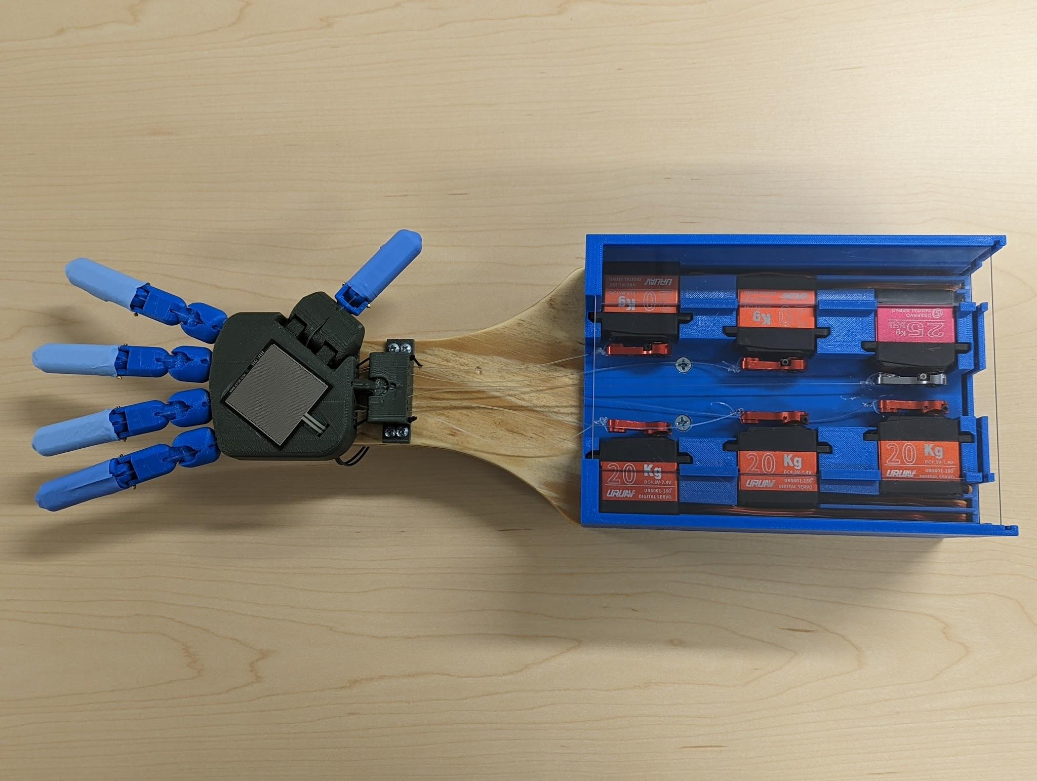
Figure 1. The complete robotic hand system

Alternative Designs and Testing
The design of the system heavily revolved around the type of joints that were chosen. Two joint types were considered, revolute joints and ball and socket joints. The revolute joint was tested with both a 3-D printed ABS plastic pin and a metal pin. In the beginning, fingers were made with a variety of combinations of these joints. Fingers were also designed with both two and three joints each. Each finger type seen in Figure 2 was designed and 3-D printed to allow for testing of the joints and fingers.

A finger with two joints was chosen over a finger with three joints because the three joints caused the fingers to curl tightly instead of positioning the fingers in a helpful gripping positing. To help determine the types of joints used, the coefficient of friction was calculated for the fingers and a tensile test was performed. The coefficient of static friction test found that, when in contact with the same wooden board, the finger with only ball and socket joints had a static friction coefficient of 0.378, while the revolute jointed finger increased the coefficient of friction to 0.49. This showed that the design of the front surface of the revolute joint was flatter, creating a better gripping surface. The tensile test was performed using the ASTM E8-16a standard ^{[11]} and showed that the ball and socket joint was the strongest joint, followed by the revolute joint with a metal pin, and the revolute joint with a plastic pin was the weakest.

Figure 2. Tested finger designs. From left to right the fingers are: the 3 ball and socket joints, 2 ball and socket joints, 1 ball and socket and 2 revolute joints with a plastic pin, 1 ball and socket and 2 joint revolute joints with metal pin, 1 ball and socket and 1 revolute joint with a metal pin

Final Hand Design
After testing the different joint types, the strength of the joints was balanced with the gripping area the finger exerted on the objects. The final design for all the fingers except the thumb contained a two jointed finger, with a ball and socket joint at the base and a revolute joint in the middle. The thumb contained a single revolute joint that partnered with the extra joint on the palm. Each finger had a channel running through the front for the tendon and a channel running through the back for a piece of elastic cord. The fingers were covered with the tip of a rubber glove to increase the coefficient of friction and help hold different objects.

The palm design, seen in Figure 3, included a corner with a hinge joint, which was angled so the thumb was positioned antipode to the pinky, which made it easier to grasp objects. Tendons ran through the hollowed-out palm. The thumb tendon was routed to the opposite side of the palm before exiting the palm towards the wrist, which aligned the tendon for entry into the wrist on a more linear path. A hook was used for the wrist tendon and thumb elastic to be tied to. The back was enclosed with a lid that fit snugly in place, which included a hole for the pressure sensor wires to exit from.
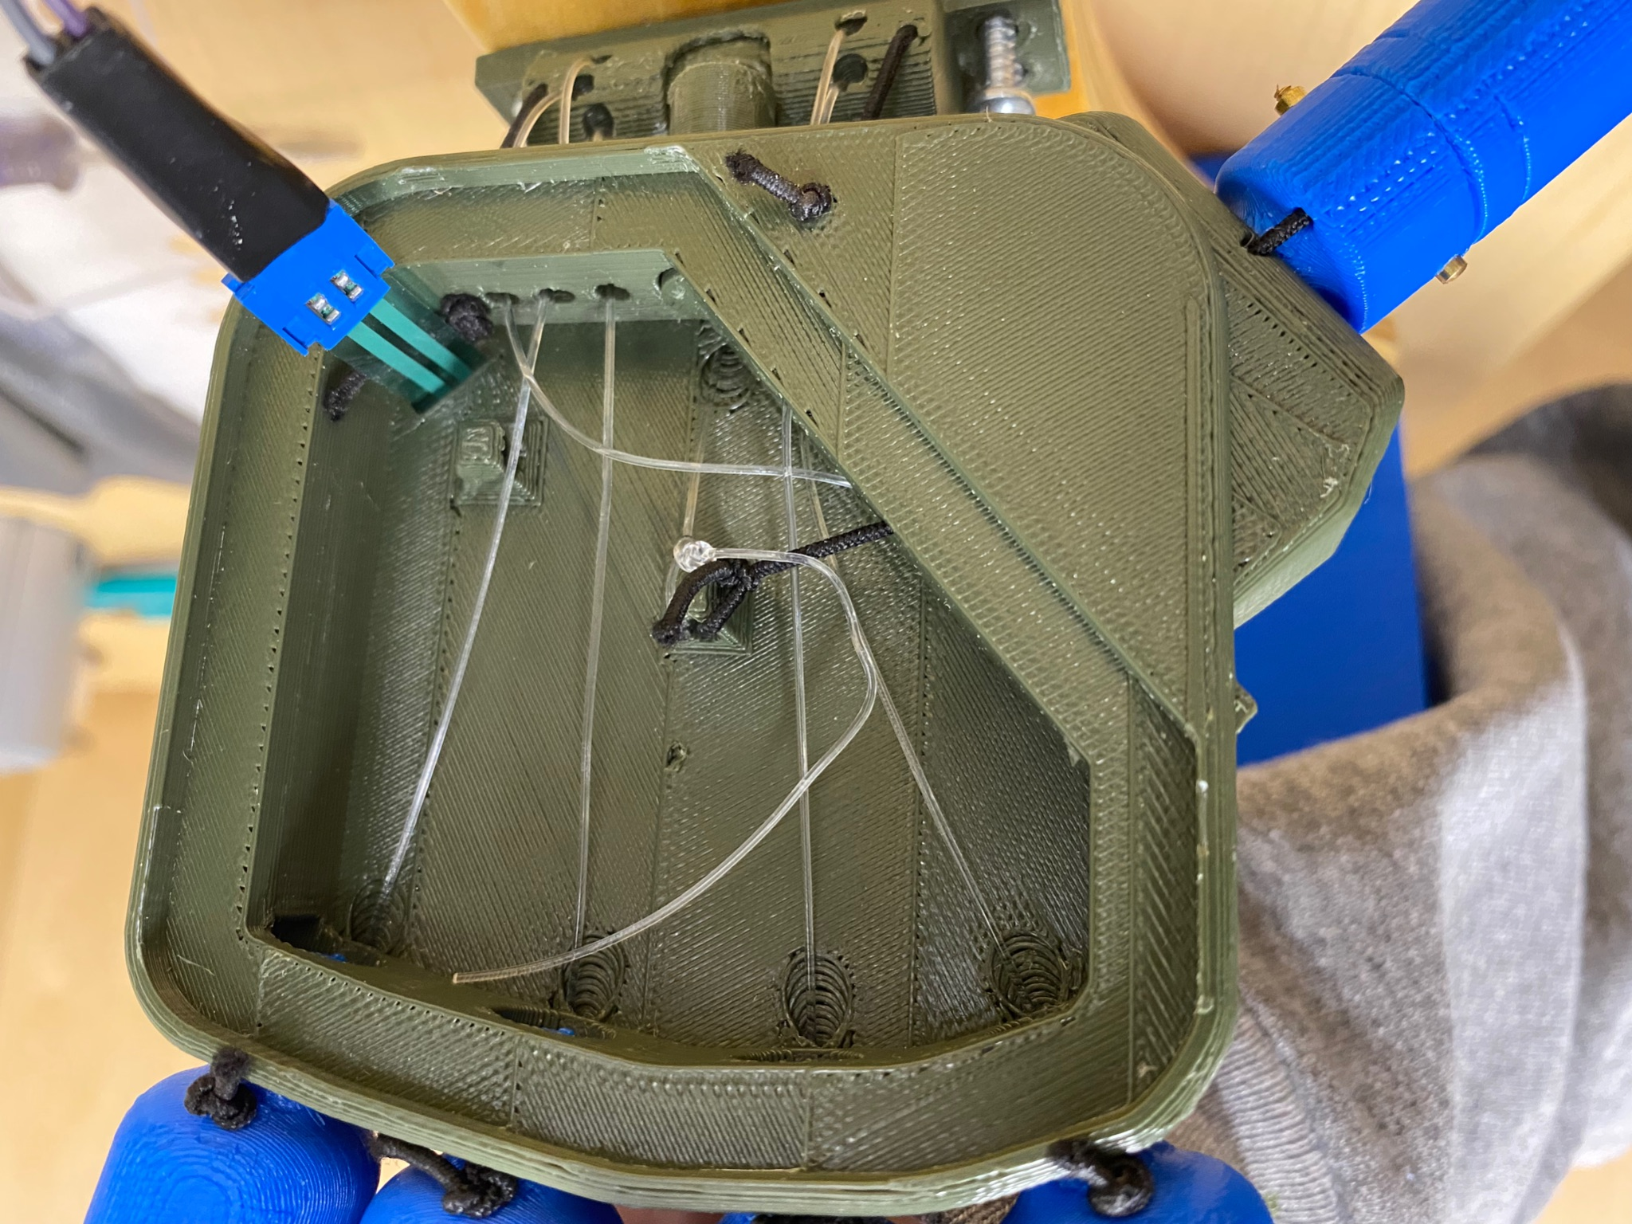
Figure 3. Final wrist design, front view (left), back view without cover (right)

The wrist, seen in Figure 4, was 3-D printed and used the ball and socket joint, which from the tensile test was found to be the strongest of the two joint types that were tested. The other purpose of the wrist was to transition the tendons to go to the servos. The tendons exited the palm in a way that avoided the place where the wrist connected to the palm and also avoided the hinged thumb joint. The channels were made so that the tendons all came out in a straight line, aligning the tendons with their servos. The addition of the wrist required at most 2.4 additional newtons of pulling force to fully flex the fingers.

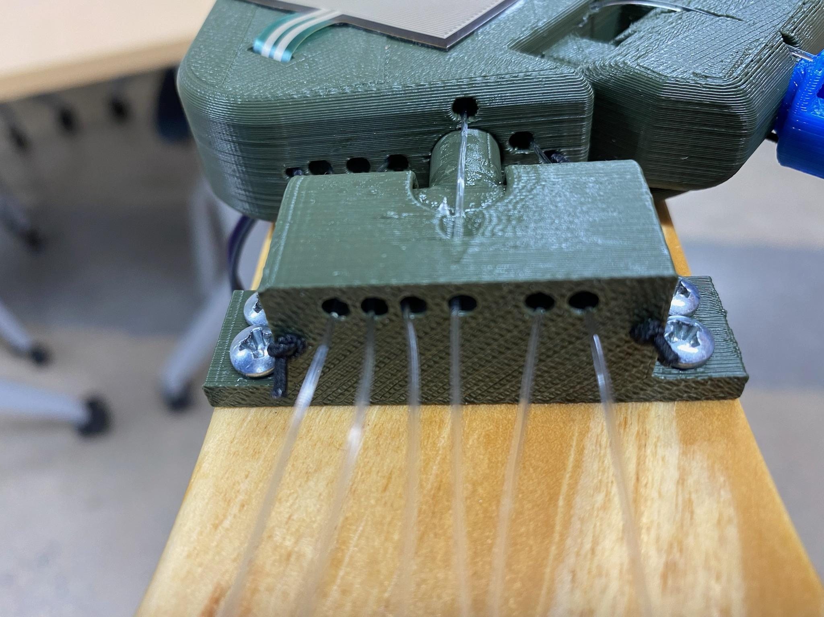
Figure 4. Rendered (left) and finalized (right) wrist design

Forearm Design
The forearm design consisted of two sections, one to house the servos and another to hold the batteries and circuit boards, each of which can be seen in Figure 5. The servos were positioned on their sides so that their arms moved in the same plane the tendons were in and the motion of their arms were limited to 180 degrees. The servos were divided into two symmetric groups and were staggered so that the tendons didn’t interfere with each other. The servos farthest from the wrist were the ones closest together, and the ones closest were the farthest apart. This added a slight angle to the direction the servos were pulled from the wrist. Testing showed that the most severe angle was 4 degrees on both the pointer finger and thumb tendons, which required an additional 0.5 newton force to pull the fingers into full flexion. This was an insignificant amount of additional force, so the servo and wrist designs were not changed.

The forearm was 3D printed to allow for a custom design that held all the parts in place as the robotic hand moved about. On the bottom of the forearm, there is an insert to fit each battery and the circuit board, secured with Velcro. On the top, there was a footprint for each of the servos to slide into, and a small piece of acrylic that slid over the servo bodies to secure them. Acrylic also surrounded the forearm structure on the top, bottom, and back, enclosing the electronics (Figure 5). The front of the forearm closest to the hand was left open for the tendons to pass through on their way to the hand. A piece of wood spanned the distance from the wrist to the forearm and was curved so that it tapered down from the width of the forearm to the width of the wrist.

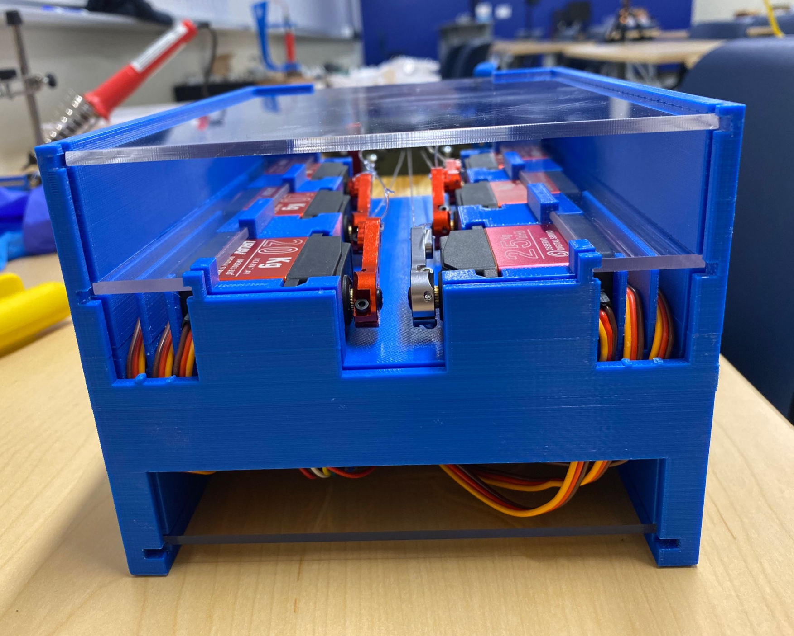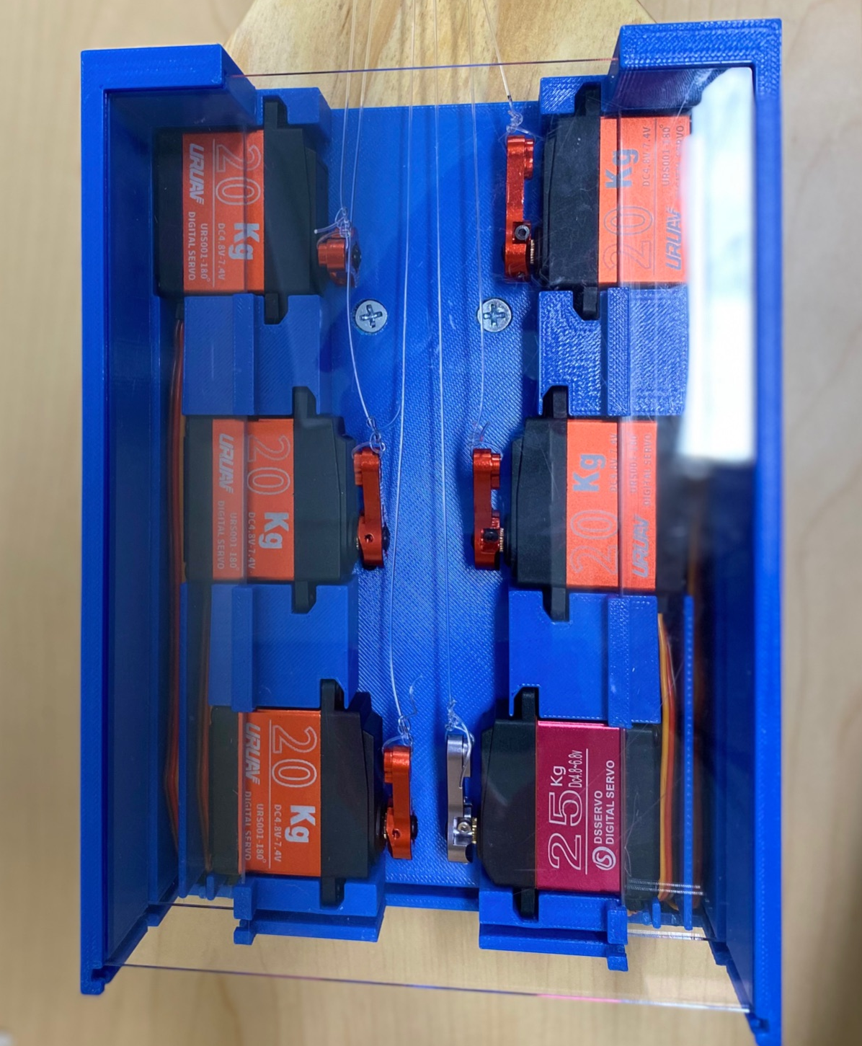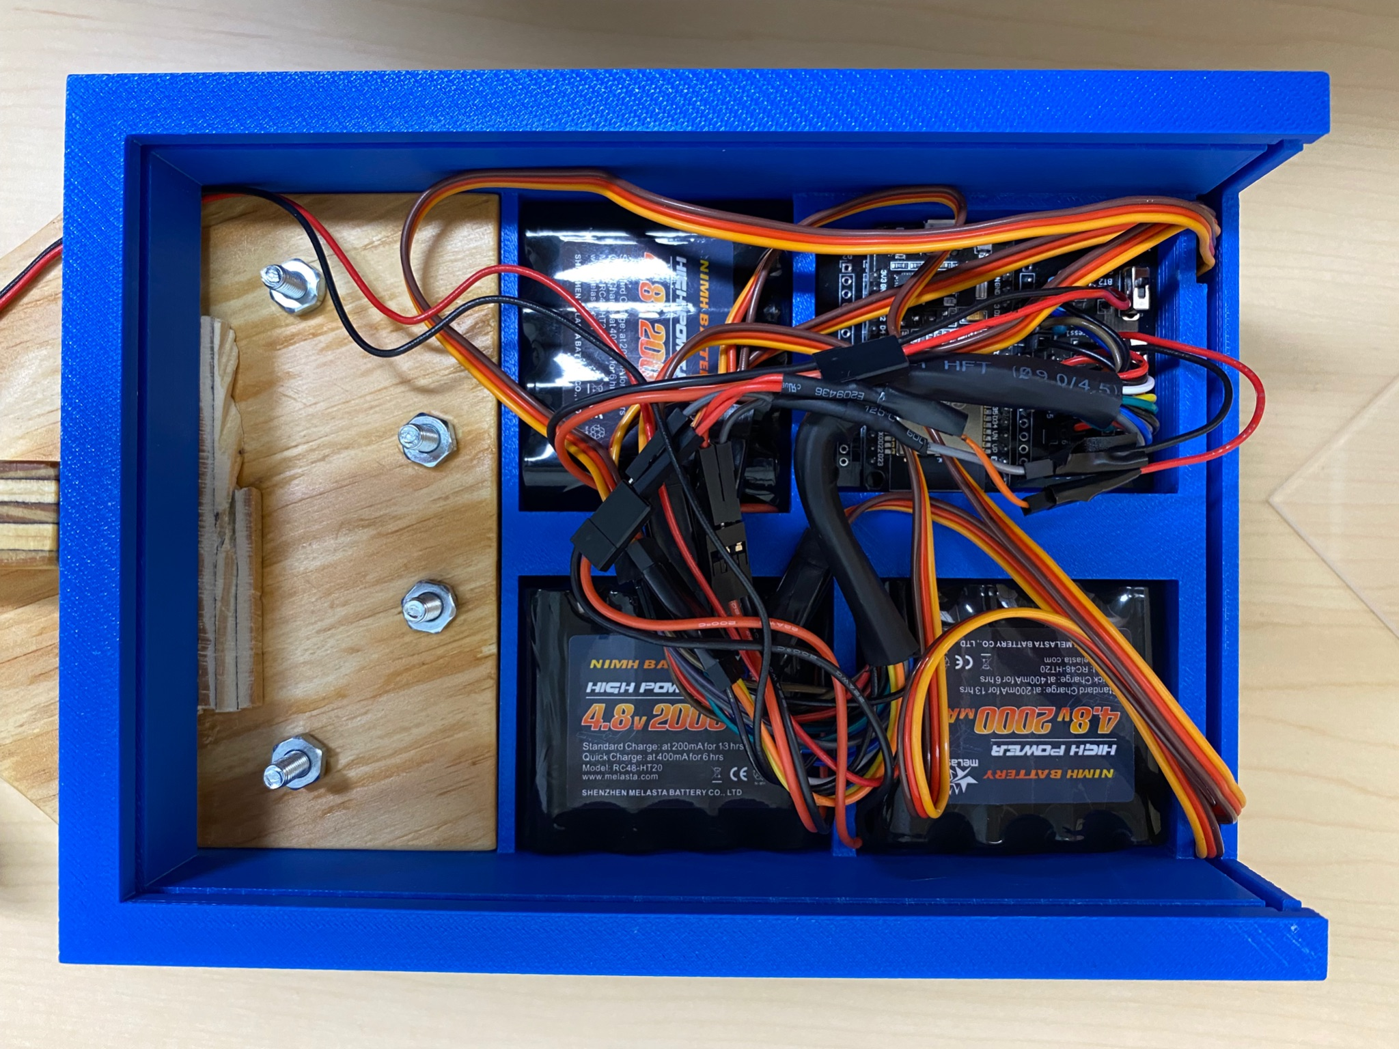
Figure 5. Forearm Design: Back view (left), Top view (middle), Bottom view (right)

Wireless Communication and Electronics

Microcontroller
The microcontroller in this project served as both the brain, doing the calculations, and the messenger, communicating back and forth. These requirements were central considerations when deciding which to use. The ESP32 was chosen as the microcontroller best suited for this project. The rationale behind choosing this board instead of a more well-known microcontroller or microprocessors, such as Arduino or Raspberry Pi, was the focus on wireless communication. The ESP32 has an integrated Wi-Fi chip that can produce 2.4 GHz Wi-Fi, Bluetooth 5 LE, and can be programmed using the Arduino IDE environment ^{[9]}. The two ESP32s used for this project communicate with each other over local Wi-Fi. Using Wi-Fi had the advantage of low latency as well as the greatly increased range over Bluetooth options. Local Wi-Fi was used because neither board needed to be connected to the internet at all, just to the other.

Signal sampling and transmission
The wireless communication system was what transported the user’s finger position to the robotic hand. Variable resistance flex sensors were attached to each finger of the glove. These flex sensors varied their resistance based on the bend radius. The bend radius of the sensor is measured by a pin on the ESP32. This value was then mapped onto a 0-180 degree range on ESP32 of the glove and then transmitted to the ESP32 of the robotic hand. This degree value was then sent to the corresponding servo motor which responded accordingly. The process was mirrored with the pressor sensor on the robotic hand palm. The pressure resistance value, dependent on the pressure on the palm, was sent from the hand to the glove where that value was assessed. All transmission was done in accordance with the IEEE ANSI C63.10-2020 standard ^{[10]}.

Electronic Circuit
For the above-described design to work, a way to measure the resistance as it changed in the pressure and flex sensors was needed. The circuits used in this project took advantage of the electronic properties of a voltage divider, as seen in Figure 6. The voltage measured at the output point can be represented with the following equation:
$V_{out}=\frac{V_{in}*R_{2}}{R_{1}+R_{2}}$,
where R₁ is the variable resistor, R₂ is a constant and known-value resistor, $V_{in}$ is a 5-volt source, and $V_{out}$ voltage was measured using an analog pin on the ESP32. Rearranged to solve for R₁, the equation becomes:
$R_{1}=R_{2}*(\frac{V_{in}}{V_{out}}-1)$.
With all of the required values, the ESP32 was able to calculate the resistance value. The vibration motor of the feedback system worked using a transistor as a switch. This will be discussed further in the glove and feedback section.
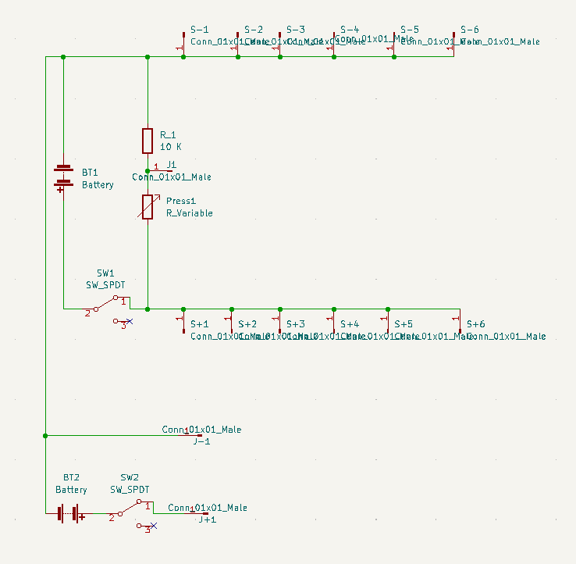

Figure 6. General voltage divider circuit
Figure 7. Circuit layout of robotic hand

The final circuit for the glove had six voltage dividers: one for each finger and one for the wrist. Each of the $V_{out}$ measurements was taken on a different GPIO pin on the ESP32. The transistor circuit from the feedback system was connected to another GPIO pin. This circuit was powered by one rechargeable 5V battery pack. The ESP32 board, voltage divider input, and the vibration motor were all powered by this common power source. There was a power switch for the user to power the circuit when in use and conserve battery power when not. The glove circuit can be seen in Figure 7.

The circuit for the robotic hand was similar. It had one voltage divider for the pressure sensor. There were six leads from the ESP32 board to the corresponding servos which ran to the servos position wire. These wires conveyed the position value after the ESP32 on the robotic hand received them. The servos power and ground were also supplied through the circuit. However, there were two separate power sources with a common ground to prevent the board from being under powered. One 5V battery pack powered the board, while two 5V battery packs arranged in parallel powered the servo motors. Because the servo current draw was unpredictable and was prone to high spikes, the increased current capacity that the parallel battery packs provided was needed. For this circuit, there were two power switches, one for the ESP32 power source and one for the servo motor power. The robotic hand circuit can be seen in Figure 8.
Programming code
Both the robotic hand and glove ESP32s were running scripts written in the Arduino IDE. The MAC address of each board was recorded in the other board’s script to define the recipient address for Wi-Fi transmission. In the code, each voltage divider signal measurement was assigned to a GPIO pin with analog/digital capabilities. To assure that the signal would not be too noisy from measurement to measurement, 15 measurements were taken and the average of them was processed further. This average value of the measurement for each voltage divider was mapped using the Arduino map function from the voltage value to a corresponding degree value before being transmitted. A ten-millisecond delay was added at the end of the script to ensure transmission could happen before the next loop would run and a new measurement would be taken.
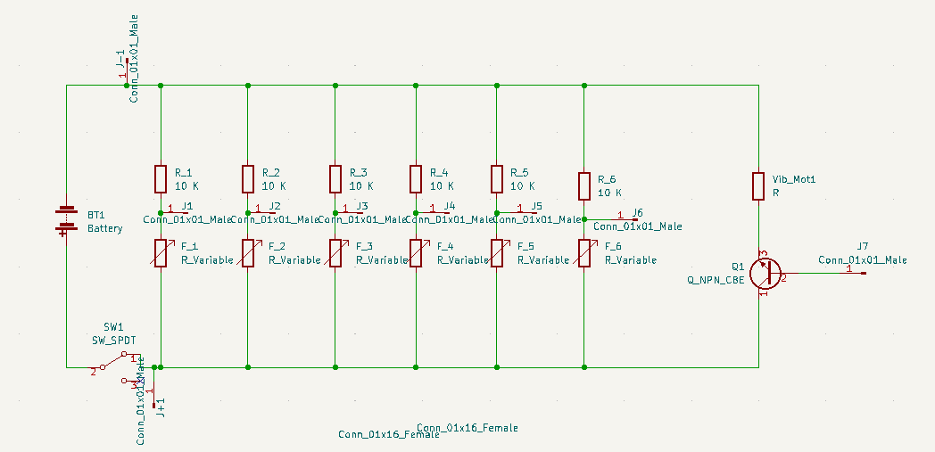
Figure 8. Circuit layout of the glove

Printed Circuit Boards
Once the circuits were finalized, they were recreated using KiCad, an online schematic, and sent off for printing by uploading the Gerber files to PCB Way. There were two boards printed, one for each system. This allowed for the pins to be changed in the code. These PCBs allowed for the project to assume a much more compact form than previous circuits which were constructed on breadboards as seen in Figure 9.
Figure 9. Glove printed circuit board with wires and components soldered on

Glove and Feedback System

The glove system, seen in Figure 10 below, included a glove with flex sensors sewn onto the back of the fingers, a 3-D printed electronics box that attached to the glove and was positioned on the user’s forearm, and a feedback system. The glove was designed to fit a wide range of users, as well as to have room for all the flex sensors. The flex sensors were hand sewn onto the back of each finger so that the sensor bent with each joint on the finger. There was also a flex sensor needed for the wrist, so the glove was chosen with a section that extended past the wrist. To accomplish all of this, a rubberized gardening glove was chosen.

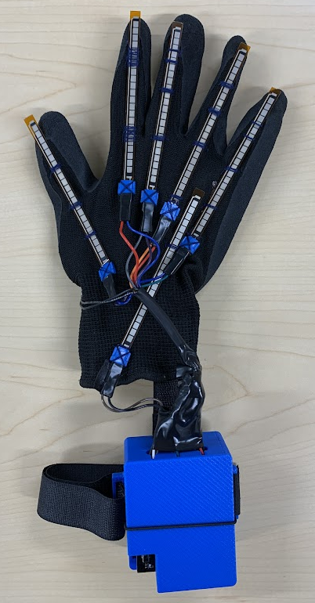
The feedback system was an important aspect of the project, as it gave the user input on how much pressure they were applying to objects. The resistance from the pressure sensor was measured using the voltage divider described in the above section. Whenever the pressure sensor reached the 30 kPa threshold on the ESP32 of the robotic hand, a message was sent to the ESP32 of the glove triggering the vibration motor. This was done by constructing the circuit seen in Figure 11, where the transistor acts like a switch. When the transistor trigger value was received from the sensor, the board switched from a low output to a high output on the lead running to the middle leg of an NPN transistor. When the middle leg read a high output, then the transistor allowed for the circuit to ground itself, therefore completing the circuit and turning the vibration motor on. The vibrational motor would stay on for 5 seconds, while the user would lose control of the servos. This acted as a precautionary measure for the robotic hand to prevent the hand from crushing any object. The feedback system can be seen in Figure 12, which shows where the pressure sensor and coin vibration motor have been placed.
Figure 11. Circuit for vibration motor
Figure 10. Final glove design
Figure 12. Pressure sensor on the robotic hand (left) and vibration motor on the user worn glove (right) used in the haptic feedback system

Since the user is directly in contact with the glove, safety was of the utmost priority in the design process. All of the electronics were completely enclosed in non-conductive materials to ensure the user will not be harmed. The rubber on the palm of the glove is non-conductive, so the coin vibration motor glued to it does not pose any chance of harm to the user. All of the wiring connections not enclosed in the housing were wrapped in either electrical tape or heat shrink, which are non-conductive to prevent the user from touching a bare wire. Most wires were placed in another section of heat shrink to provide cable management to the glove.

Another safety feature was the 3-D printed box that housed the PCB circuit board and battery. The non-conductive housing had a Velcro strap to go around the user’s forearm, as well as Velcro to connect it to the glove. This design allowed the box to be removable while also making the glove and board housing a single system. Continuing with the housing design, there were slots for the wires that attach to the flex sensors and vibrational motor to go through. The slots also acted as a ventilation system with additional holes to prevent the PCB and battery from any chance of overheating. The housing was also designed with a cutout in the lid to make the power switch easily accessible for the user. The lid was completely removable for ease of access to the components inside and was a friction fit on the box that uses an elastic strap to secure it further. The cutout is only big enough to fit the switch to prevent the possibility of the user touching any other part of the circuit.

4 Results and Further Improvements

Once the robotic hand and glove were integrated with the electronics, the project was evaluated through several tests. A latency test was completed to determine the delay between the glove and the robotic hand. A grabbing test was also completed to discover the range of shapes of objects the robotic hand could grasp. Testing was also completed to find the range of the wireless communication system. And finally, the process and final design were evaluated for further improvements.

Latency
The hand had a minimal latency overall. There was no measurable delay for connection time upon start-up. The hand also responded quickly to user movements. There was a 96-millisecond delay between when the user started a movement to when the corresponding servo started moving. This delay was partly due to a 10-millisecond delay in the code. There was a larger delay when looking at the time it takes to complete a full range of motion, from fully extended to fully bent. In that extreme case, it took servos an average of 0.72 seconds longer to complete the full range of motion than the human hand, largely due to the speed capability of the servos.

Grabbing Tests
The robotic hand was able to grab, pick up, and hold objects of varying sizes and weights. The purpose of this test was to determine the size of objects rather than the weight that the hand could hold. Items such as a can of soda, a tennis ball, and a tape measure were able to be picked up by the hand. A drill was attempted to be held but the stress in the wrist caused the wrist to break. The hand also didn’t have the capability to hold very small objects, as the fingers did not reach all the way to the wrist when completely flexed. The final design met the initial goals of the project – grabbing golf ball to tennis ball size range (40-70mm), and other objects in the range of objects often grasped by human hands.

Range Test
Testing was done to determine the maximum range the system had. Without obstruction, the user-worn glove could be 44.5 meters away from the robot hand and still constantly control the hand. For distances further than 44.5 meters the connection became unreliable. The system could control the hand through walls, but the range was shortened.

Future Improvements
There were several areas of improvement for the project if it were to be developed further in the future. The wrist proved to be a limiting factor in some of the testing when it came to lifting objects in certain orientations as it was the first thing to break. To fix this, a stronger wrist that is either thicker or made of a stronger material could be used.

The hand was best used when the palm was facing up or to a side. The hand did not perform well when the palm was pointing down, as the elastic in the wrist was not strong enough to keep the robotic hand from flopping over. To improve this, the current elastic cord could be replaced with stronger ones. However, the elastic strength needs to be balanced with the additional force required to pull the wrist to its bent stage. For this reason, it may be beneficial to also consider an active extension method for the wrist, such as another servo-tendon system.

5 Conclusion

All three parts of this project, the robotic hand, glove and feedback system, and wireless communication and electronics were integrated together to bring this project to completion in the view of the objectives. The robotic hand was able to meet the goals of picking up and holding a golf ball to tennis ball sized object (40-70mm). It was also able to pick up and hold other irregularly shaped objects that ranged up to at least 575 grams (1.26 lbs). The latency was indeed reasonable, and while it did have some delay the user was not hindered. These numbers met the objectives set at the beginning of the project.

While this project has demonstrated that the robotic hand and glove function, it still doesn’t have a clear utility. Ultimately, for this project to be applicable, it needs to be paired with other technologies. These uses could happen near chemical solutions, dangerous machinery, manufacturing assembly lines, and even space applications. This would prevent the need for a human to physically be in these places, potentially endangering them. What separates this project from previous ones is now a user could be in a safe place and still manipulate objects by hand to get tasks completed. Human control by way of hand position mimicking can allow for a more intuitive robotic hand operation experience.

Acknowledgments
This project would not be possible without the support of the Eastern Mennonite University Engineering Department.

References

[1] McKinley, O’Loughlin, and Pennefather-O’Brien (2020) Appendicular Muscles. Human Anatomy (6th ed., pp. 360–368). McGraw-Hill Education
[2] C. S. Lovchik and M. A. Diftler (1999) The Robonaut hand: a dexterous robot hand for space. Proceedings of the 1999 IEEE International Conference on Robotics and Automation (Cat. No.99CH36288C), pp. 907-912 vol.2, doi: 10.1109/ROBOT.1999.772420
[3] I. Gaiser et al. (2008) A new anthropomorphic robotic hand. Humanoids 2008 - 8th IEEE-RAS International Conference on Humanoid Robots, pp. 418-422, doi: 10.1109/ICHR.2008.4755987
[4] Mavroidis, C., DeLaurentis, K. J., Won, J., and Alam, M. (2001) Fabrication of non-assembly mechanisms and robotic systems using rapid prototyping. Journal of Mechanical Design, 123(4), 516–524. https://doi.org/10.1115/1.1415034
[5] Almassri, A. M., Wan Hasan, W. Z., Ahmad, S. A., Ishak, A. J., Ghazali, A. M., Talib, D. N., & Wada, C. (2015) Pressure sensor: State of the art, design, and application for Robotic hand. Journal of Sensors. Retrieved October 2021 from https://www.hindawi.com/journals/js/2015/846487/
[6] S. Li, X. Tong, J. Huang, X. Wu, W. Yang and Z. Pan (2020) A Thermal and Vibrational Feedback Glove Based on the Tactile Characteristics of Human Hand Skin. IEEE Access, vol. 8, pp. 226671-226684, doi: 10.1109/ACCESS.2020.3045614.
[7] Hinchet1, R., Vechev, V., Shea1, H., and Hilliges, O. (2018) DextrES: Wearable Haptic Feedback for Grasping in VR via a Thin Form-Factor Electrostatic Brake. Proceedings of the 31st Annual ACM Symposium on User Interface Software and Technology. https://ait.ethz.ch/projects/2018/dextres/downloads/dextrES.pdf
[8] Miller, J., Braun, M., Bilz, J. et al. (2021) Impact of haptic feedback on applied intracorporeal forces using a novel surgical robotic system-a randomized cross-over study with novices in an experimental setup. Surgical endoscopy vol. 35, 7: 3554-3563. doi:10.1007/s00464-020-07818-8
[9] Institute of Electrical and Electronics Engineers Standards Association (2020). American National Standard of Procedures for Compliance Testing of Unlicensed Wireless Devices (ANSI C63.10).
[10] ESP32­C3 Series Datasheet (2022). Espressif Systems. https://www.espressif.com/sites/default/files/documentation/esp32-c3_datasheet_en.pdf
[11] American Society for Testing and Materials International (2016). Standard Test Methods for Tension Testing of Metallic Materials (E8/E8M - 16a).

