Community-Wide Prevention of COVID-19:
A Systematic Analysis of Hot vs. Cold Spots

Mackenzie Davis1, Zachary Mastrich¹, Rachel Tuosto¹, Samuel L. Browning¹, and E. Scott Geller¹
1Virginia Polytechnic Institute and State University (Virginia Tech)

April 17, 2021

Abstract

Universities in five different states are collaborating on an original large-scale COVID-prevention effort by asking many of their students to complete an innovative survey that strategically asks them to identify areas on and around campus that are “hot spots” for spreading the coronavirus. These universities—Virginia Tech, Appalachian State, Western Michigan, University of Kansas, and University of Florida—are also observing mask wearing, social distancing, and other COVID- prevention measures in their communities to analyze the risk management and wellness precautions taken by students, faculty, and the public on campus and throughout surrounding communities. Mapping hot spot areas provides invaluable information for prevention and intervention creation.

Introduction

In the new COVID-19 world, much is unknown about what precautionary measures are practiced throughout various communities, and which are relatively effective. This community-based field research observed and evaluated the risk-management and wellness precautions taken by students, faculty, and the public on campus and in the surrounding communities. College towns have evidenced increasingly high rates of COVID infection since students returned to school in August of 2020. Given this statistic, we explored which areas of these college towns participants would identify as relatively ‘at-risk’ and ‘non-risk’ for the spread of the coronavirus. Heat maps were used to assess the areas on and off campus to reflect where the most and least mask wearing was observed. At-risk and non-risk areas were determined by observations made by the participants. They selected locations on two maps, one of Virginia Tech’s campus and one of Downtown Blacksburg. Their selections automatically generated a ‘hot spot ‘on each map. Separate maps were used to examine most facemask wearing and least facemask wearing both on and off campus.

Collecting and displaying observations of at-risk and non-risk areas provide invaluable information for prevention and intervention. We hypothesized that on-campus dining halls and dorms would be the areas most at risk, and academic buildings on campus would evidence the most non-risk areas. We also expected off-campus bars to be the most at-risk for the spread of COVID-19.

Method

The 25 participants were undergraduate students from a large land-grant university in the Southeastern United States. This research was conducted as a preliminary study, expected to be administered to large introductory psychology classes on our campus and at four other universities—University of Kansas, Western Michigan University, University of Florida, and Appalachian State University in the fall. All participants in this study were recruited through classes and on-campus organizations. Students’ psychology classes were awarded extra credit points for their participation. Once students agreed to participate, they were directed to a link for an online Qualtrics survey. The participants completed an online questionnaire designed to assess areas where they had observed at-risk and safe behavior regarding the spread of COVID-19.

Upon completion of the survey, students were given extra-credit for their participation. The survey was administered through Qualtrics Survey Software and took 20-30 minutes to complete. It consisted of a series of both short-response and close-ended survey questions addressing personal experiences with COVID-19 prevention behaviors. Participants recorded where they noticed the most and least amount of mask wearing during different times of the day on a series of maps of on-campus and off-campus locations. These selections enabled the generation of “heat maps” to indicate the locations of the at-risk and non-risk areas for the spread of COVID-19.

Results & Discussion

The Qualtrics survey and heat-map analysis revealed that facemask wearing was more consistent in areas with a higher probability of receiving a negative consequence for noncompliance. The heat maps use coordinate data that represent the areas selected by participants to generate a ring- like structure with the deepest reds and blues showcasing the areas that were selected most often, and less opaque shades of these colors depicting the surrounding areas that were selected less often.

The bars in Blacksburg, VA were the riskiest hot-spot areas. The at-risk areas on campus were identified as mainly the Drillfield—a large recreational space at the center of campus—despite the restrictions in place. The non-risk or most safe areas on campus were mainly academic buildings and the library. The non-risk areas off campus were identified on the edge of campus—areas where restrictions were also more prominent. The sample of 25 students reported other COVID-19 prevention measures they accomplished ‘most of the time,’ like wearing a facemask in public and avoiding gatherings of 50 or more people. The same sample of students reported COVID-prevention behaviors such as touching the face and avoiding gatherings of 10+ people as accomplished ‘not at all’.

Figure 1 shows each heat map, depicting areas with the least amount of mask wearing off-campus and on-campus areas during peak hours of the day. Peak hours, the times of day with most congestion for on- campus areas were determined to be 12:00-3:00pm, times when most students are in class. Peak hours for off campus were 5:00-10:00pm, when restaurants and bars are the busiest. Figure 2 shows each heat map, depicting areas with the most amount of mask wearing off-campus and on-campus during peak hours of the day. Both figures can be interpreted by the differing colors, with red being the largest concentration of observations of mask wearing, and blue being the least concentration of observations. The ‘hot spots’ are noted as the mostly red areas with the outward rings displaying lighter colors as ‘heat’ fades.

Figure 1: Heat Maps of the Least Amount of Mask Wearing On and Off Campus
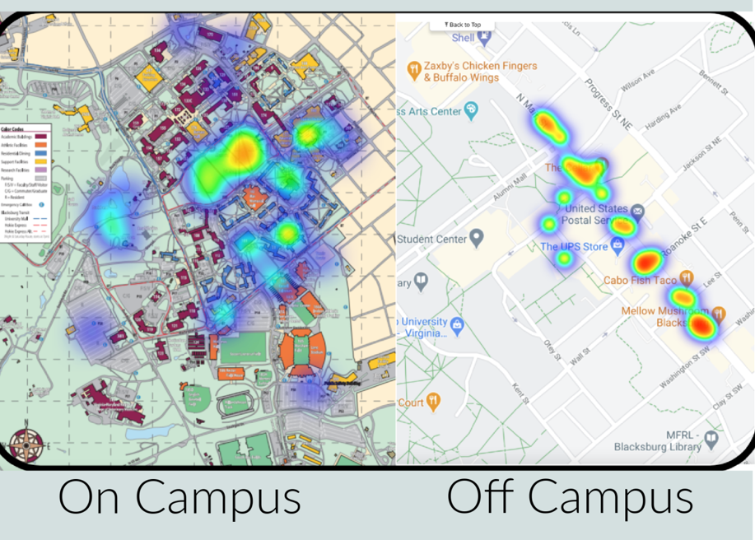

Figure 2: Heat Maps of the Most Amount of Mask Wearing On and Off Campus

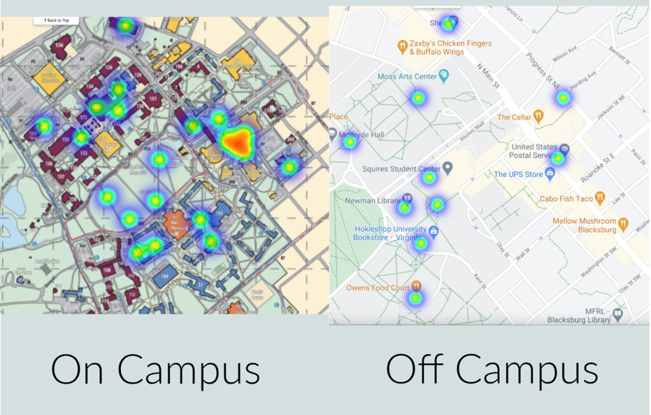

Conclusion

This study introduced a reliable and practical COVID-prevention survey to assess the risk of being infected with the coronavirus in any area involving human interaction. The identification of at-risk (i.e., hot) and non-risk (i.e., cold) areas in college towns enable professionals to examine these zones for further implementation of protection interventions.

This study provided a map of COVID-19 hot spots in and around a campus community by implementing a practical survey process any community could use for large-scale prevention of COVID-19. Future research should analyze the need to measure perceptions of safe and unsafe spots longitudinally, and thereby evaluate changes in COVID-prevention behavior over time, which could change as a function of changes in social norms and perceptions regarding the risk of being infected with COVID-19. A critical limitation of this research is that the participants included only university students, thereby narrowing the range of judgments for select areas in the community. Also, while the sample size was quite small, this preliminary research sets the stage for a large-scale assessment of COVID-19 hot and cold spots at five large universities in the near future.

5 References

Barrios, L. C., Riggs, M. A., Green, R. F., Czarnik, M., Nett, R. J., Staples, J. E., Welton, M. D., Muilenburg, J. L., Zullig, K. J., Gibson-Young, L., Perkins, A. V., Prins, C., Lauzardo, M., Shapiro, J., Asimellis, G., Kilgore-Bowling, G., Ortiz-Jurado, K., & Gutilla, M. J. (2021). Observed facemask use at six universities - United States, September-November 2020. MMWR. Morbidity and mortality weekly report, 70(6), 208–211. https://doi.org/10.15585/mmwr.mm7006e1
Eichler, S. E., Hopperton, A. P., Alava, J. J., Pereira, A., Ahmed, R., Kozlakidis, Z., Ilic, S., & Rodriguez-Palacios, A. (2020). A citizen science facemask experiment and educational modules to improve coronavirus safety in communities and schools. Frontiers in Medicine, 7. https://doi.org/10.3389/fmed.2020.00486
Gehlenborg, N., & Wong, B. (2012). Heat maps. Nature Methods, 9(3), 213–213. https://doi.org/10.1038/nmeth.1902
He, J., He, L., Zhou, W., Nie, X., & He, M. (2020). Discrimination and social exclusion in the outbreak of COVID-19. International Journal of Environmental Research and Public Health, 17(8), 2933. MDPI AG. Retrieved from http://dx.doi.org/10.3390/ijerph17082933

