Strategies for coupling photon-upconverting nanoparticles with photoactive protein therapeutics

Michael G. Bibbey1, Jennifer N. Cha1,2
1Department of Chemical & Biological Engineering
2Materials Science and Engineering Program, University of Colorado, 596 UCB, Boulder, Colorado 80303, United States

May 15, 2021

Abstract
anomedicine is a rapidly advancing field as capabilities in nanoscale materials, devices, and sensing grow. Biocompatible nanoparticles have made their way into the pharmaceutical and biomedical market in imaging, diagnosis, and targeted drug delivery. Similarly, protein therapeutics show promise for their unique combination of high biospecificity and diverse function. This brief perspective explores the merging of these two fields via light-controlled methods mediated by photon-upconverting nanoparticles. The framework of three photoactive protein therapeutic systems will be explored for their integration with upconverting nanoparticles.
N

Introduction

Nanomedicine
The field of nanomedicine differs from traditional approaches to medicine due to an emphasis on the novel material properties and capabilities which occur at the nanoscale by harnessing molecular and atomic structures. The field has implications in imaging, materials, devices, and therapeutics. For example, nanocarriers such as Doxil and Abraxane are used in the clinic today for cancer treatment due to their ability to minimize side effects and improve targeted delivery (Ventola, 2012). The promise of nanoparticles (NPs) extends into imaging and diagnostics with MRI and NP-bound antibodies to sense cancers, and some speculate NPs may help address the delivery of drugs across the challenging blood-brain barrier (Bhaskar et al., 2010). Due to the widespread and pragmatic impact of this field of research, nanomedicine is of interest to biotechnology and pharmaceutical companies alike.

Protein therapeutics
Though a host of macromolecules play a role in nanomedicine, proteins are of particular interest for therapeutics and drug delivery due to their diverse function in the body. One of the advantages of protein-based therapies is that proteins offer highly specific and complex purposes which cannot be replicated by small-molecule drugs. This specificity also means that the risk of protein therapeutics interfering with healthy, normal biology is lessened. Also, the natural occurrence of proteins in the body lessens the risk of a hostile immune response (Carter, 2011).
Of the several hundred commercially approved therapeutic proteins, much of the market surrounds man-made monoclonal antibodies produced by the single clone of a particular cell line (Vaishya et al., 2015). Monoclonal antibodies have become a favorite option for treating various forms of cancer in the clinic. They are appealing for their high biospecificity for particular cell receptors and ability to tightly bind them. Once bound to overexpressed receptors, antibodies have the unique ability to inhibit the binding of growth factors, recruit an immune response, or even act as a vehicle to deliver chemo drugs.
However, there are several drawbacks and challenges which antibodies face in oncology. First, antibodies are large molecules and their hydrodynamic Stokes radii prevent their diffusion into the dense cellular matrices of tumor tissue (Xenaki et al., 2017). Next, antibodies’ tight binding of their respective receptor or antigen is so strong that it leads to a low dissociation constant (K_{D}) which prevents permeation past the outer layers of the tumor bed (Brasino et al., 2018). Lastly, once the antibody-receptor complex is endocytosed into the cell, antibodies can undergo rapid lysosomal degradation and the receptor is recycled to the membrane free of the antibody (Xenaki et al., 2017). Together, these issues are called the “barrier effect”. This limits the effective time that the antibody is able to be useful for therapeutic purposes such as drug conversion or inhibiting the binding of growth factors.

Light in nanomedicine
One of the many appeals of working in the nanoscale is that the engineer is able to harness quantum and atomistic behaviors of materials in addition to other material properties. Consequently, the use of light and various wavelengths of electromagnetic radiation meshes well with nanoengineering.
The transmission of light through tissue is nontrivial due to the complicated cocktail of optical properties present; some biomolecules readily absorb or reflect certain wavelengths and others bend and scatter light if transparent. This makes visible and UV penetration into tissue fairly limited, but wavelengths in the near infrared (NIR) are permeable into the body (Zhang et al., 2016). This ability to reach deep tissue is appealing for purposes such as treatment and imaging.
Light can also be used to interact with photoactive therapies. Radiation of light into tissue can act as a remote trigger for drug delivery causing the release, transformation, or degradation of drugs. This allows for targeted and highly controlled dosages. Various methods can be used to accomplish this. Treatments themselves can be engineered to be photoactive, photocaged, or photoswitchable where they are triggered by incident light (Tong & Kohane, 2012). Alternatively, photoactive reagents can be used to impart physical or chemical changes to the surrounding environment to kill unwanted cells in the case of methods such as photothermal and photodynamic therapy.
Though the use of light in nanomedicine is promising, it can cause damage. For example, the use of IR can cause photothermal damage, where the absorption of light heats tissue, damaging delicate cellular and molecular structures such as proteins. Furthermore, photochemical damage can occur as result of exposure to high intensity or high energy radiations. For example, UV can cause the initiation of pyrimidine dimerization in DNA, leading to melanoma (skin cancer).

Photon-upconverting nanoparticles (UCNPs)
Photon-upconverting nanoparticles (UCNPs) are a subset of nanoparticles which display an unusual mechanism to emit light at a shorter wavelength (higher energy) than the incident light the particle absorbs (Wang & Liu, 2009). This photon upconversion is a physical process called anti-Stokes emission which relies on the metastable and long excited states which can be achieved in rare-earth elements (lanthanides, yttrium). UCNPs are of interest for biomedical applications due to their consistent and significant anti-Stokes upconversions of more than 400 nm from tissue permeable IR to useful UV (Wang & Liu, 2009). Essentially, UCNPs offer a method to transform IR (tissue permeable, low energy, low photochemical risk) to UV (non-tissue permeable, high energy, high photochemical risk) in specific regions of the body, lowering risks and improving the ability to feasibly interact with photoactive nanomedicine treatments that trigger in the UV.
Furthermore, UCNPs are promising in the way they interact with biological systems. In vivo, nanoparticles take part in the enhanced permeability and retention (EPR) effect where nanoparticles preferentially accumulate in tumors due to their leakier vasculature (Shi et al., 2020). This is appealing because it limits nanoparticle transport throughout the body and improves targeted delivery. Via surface modification, UCNPs can also be coated to be nontoxic and inert while maintaining their upconversion ability (Wang & Liu, 2009). The coated UCNPs can also be decorated with biomolecules such as proteins.

Prospective photoactive protein therapeutics

Novel anti-EGFR photo-crosslinkable affibody
Recently, our group has engineered an antibody mimetic protein called an affibody which creates a covalent photo-crosslink with overexpressed epidermal growth factor receptor (EGFR) in cancer cells upon exposure to near UV. The affibody is designed to address many of the shortcomings of other protein therapeutics such as monoclonal antibodies. A standard monoclonal antibody is ~150 kDa and due to this large size succumbs to the barrier effect and other pharmacokinetic challenges (Ryman, 2017). Our affibody (called N23BP) is ~6 kDa—about 4% the molecular weight of an antibody and readily diffusible into tumor models. Though comprised of essentially 3 alpha helices, the affibody shares a similar binding function and affinity for EGFR as seen in antibodies. The design of N23BP is based on Z_{EGFR:1907} (a template affibody with affinity for EGFR), but contains a 4N-maleimido-benzophenone modification to a cysteine which facilitates the photo-crosslink with EGFR (Brasino et al., 2018).
Our goals with this protein are two-fold: a.) sustained, targeted drug delivery deep in tumor tissue and b.) inhibiting growth and proliferation through prolonged cellular quiescence with sustained membrane expression. These objectives are achieved through N23BP’s high diffusivity in tumors due to its small size and the covalent photo-crosslink’s ability to make N23BP a sustained fixture on the membrane. Extensive data supports the occurrence of this crosslink and suggests that the crosslink virtually eliminates cellular attempts to lyse and digest N23BP from EGFR upon endocytosis (Brasino et al., 2018). This leads to days of expression on the membrane, a massive improvement from the 4 hours that can be expected of a wild type affibody (Brasino et al., 2018). This sustained membrane modification is exciting because it makes N23BP an excellent docking point to deliver chemo drugs.
To deliver drugs, a cytosine deaminase (CodA) enzyme was engineered into a second domain of N23BP to convert inactive prodrug 5-fluorocytosine to the chemo drug 5-fluorouracil. Studies show that the photo-crosslinked N23BP-CodA protein was highly effective for drug delivery, approaching the baseline toxicity of the chemo drug over a 48-hour period (Roy et al., 2019). The inhibitory effects of N23BP have been well explored as well, demonstrating excellent proliferation inhibition in comparison to Cetuximab (a commercially available anti-EGFR monoclonal antibody for cancer treatment). When crosslinked, N23BP demonstrated the ability to increase the cell population doubling time by nearly 100% of that of a control. In investigating the biochemical response, it was found that UV irradiated N23BP itself was essentially nontoxic, meaning that tumor growth was indeed being inhibited and that the protein itself was not causing cell death upon binding. The low cytotoxicity of N23BP itself makes it an even more appealing therapeutic agent. In terms of what sort of inhibition was occurring, metabolic studies demonstrated reduced ERK activity (metabolic activity triggered by EGFR binding growth factor). Finally, it was deduced via cell cycle analysis that N23BP may induce cellular quiescence as a majority of cells treated with photo-crosslinked N23BP were in a G0/G1 phase as opposed to a wide distribution throughout the cell cycle seen in a control.
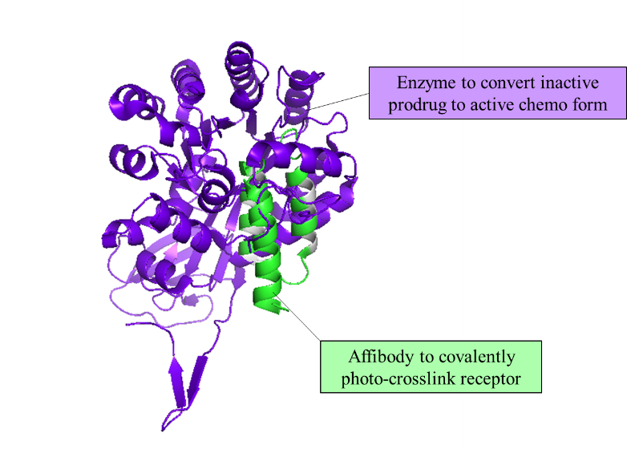
Figure 1: Rendering of affibody-enzyme fusion protein engineered by encoding two functional domains into a single peptide chain.

Antibodies with genetically incorporated photocaged amino acids for binding and delivery
Researchers Bridge et al. developed a photoactive antibody (7D12pcY) for the purpose of external modulation, similar to our group’s aim. The 7D12 antibody fragments were genetically modified using site-specific swapping of individual tyrosine residues to photocaged tyrosine (pcY), essentially inactivating (decreasing affinity by ~20 times) the binding function of 7D12pcY mutants until exposed to near UV (Bridge et al., 2019). The UV exposure uncages the tyrosine residues and restores binding affinity. The key difference between the N23BP affibody and mutant 7D12pcY antibody is that N23BP establishes a covalent bond, while 7D12pcY does not. Extensive computational work into the molecular dynamics of the 7D12 mutant was done to better understand the 7D12pcY-EGFR interaction and dependence on the photocaged tyrosine.
The photoactive 7D12pcY also demonstrated the ability to deliver small molecule payloads (fluorophores were used in the experiment) to cancer cells with overexpressed EGFR when prompted by light (Bridge et al., 2019). This study was intended to demonstrate the potential extension into targeted, light-activated drug delivery similar to that achieved with N23BP. The results here are a step forward in an approach to creating photoactive protein therapeutics which may be high adaptable from present monoclonal antibodies, improving the specificity and control of current antibody treatments. While N23BP addresses many of the issues with antibody-based treatments (which still exist in a 7D12-based modality), the mutant 7D12pcY does show the potential to adapt and enhance current drugs.

Photoactivated polymer matrices for protein release and delivery
Another modality of delivering protein therapeutics using light is the use of photoactivated depots (PADs) (Jain et al., 2012). PADs are insoluble nanomaterials which carry a payload and release a therapeutic agent when triggered by light due to a chemical or physical change with occurs to the PAD itself (Sarode et al., 2016). One example that has been explored is PADs carrying insulin—an essential protein for the control of blood glucose levels. Diabetics do not naturally produce insulin and are burdened with multiple injections of insulin daily or administration via external insulin pumps. In vitro studies show the use of PADs which only release insulin upon irradiation in the near UV generated by an LED (Jain et al., 2012). This could be a favorable method for delivering various types of proteins due to the immediate release of the protein therapy within the body and the slow biodegradation of the polymeric PAD material matrix. This could be useful in cases where the chronic physiological demand for therapy may fluctuate or need dosages throughout the day, similar to the need for insulin in diabetics. In the literature there are a variety of PADs (or other similar photoactive polymeric materials) coupled with proteins therapeutics, including materials such as gels active in the visible light region or others active in more energetic UV (Basuki et al., 2016).
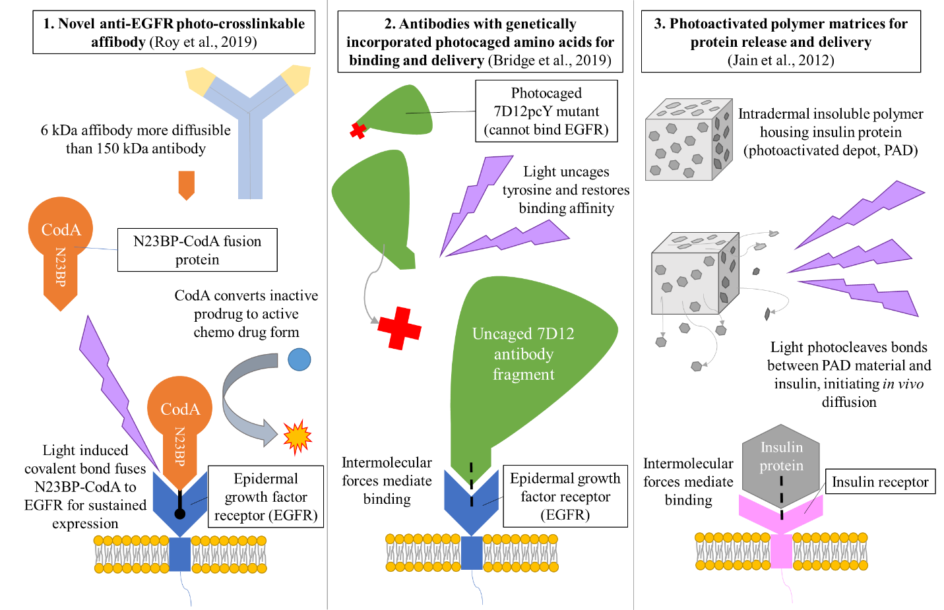
Figure 2: Comparison of prospective UV-photoactive protein therapeutic modalities.

Advancement via UCNPs
The promise of these three frameworks is heightened when paired with the capabilities of UCNPs. First, all three methods rely on high energy wavelengths of UV or visible light which do not permeate tissue well. UCNPs offer an excellent solution to this problem where IR can be used to enter the tissue and then transform into useful UV to interact with these protein therapeutics. Furthermore, this reduces the risks of harmful UV causing photochemical damage to surrounding cells, including potentially healthy tissue, because the UV light will only be generated in the presence of UCNPs. IR light is also highly controllable, meaning a clinician could apply IR very near the desired therapy location on a patient’s anatomy, improving the focus and control of the therapy. UCNPs surface modification could also make them excellent nanocarriers for protein therapeutics. In doing so, UCNPs carrying protein therapeutics would preferentially accumulate in tumor tissues due to the EPR effect. When photon upconversion occurs, the UCNP-protein complex could be engineered to both photorelease (via a photocleavable linker) and subsequently photoactivate the therapy. For example, a UCNP decorated with N23BP could be deployed into the body, accumulate in tumor structures, and when gently irradiated with NIR both release and photo-crosslink N23BP to EGFR where N23BP could facilitate extended chemo delivery and inhibit tumor growth. UCNPs present an eloquent solution to advancing the reality of these therapies.

Conclusion
The nanomedicine field holds various exciting technologies which capitalize on the unique phenomena which occur at this scale, such as using light-mediated interactions to power therapies, imaging, and diagnostics. Various protein-based therapeutic agents have been engineered to have special photoactive functionalities; N23BP is a photocrosslinkable affibody designed to increase therapeutic efficiency and inhibit tumor proliferation, 7D12pcY is a genetically modified antibody with the ability to be activated by light and deliver small molecule payloads, and a wide range of polymeric PADs can release proteins when irradiated. These methods all share the opportunity for advancement by way of incorporating UCNPs into their procedure. UCNPs offer an avenue to actually complete these photoactive tasks in the body while lowering risks and potentially acting as a better carrier to bring protein therapeutics to tumors sites where UCNPs accumulate. The combination of these nanomedicine techniques is an excellent prospect for improving treatments and patients’ lives alike.

References
Basuki, J. S., Qie, F., Mulet, X., Suryadinata, R., Vashi, A. V., Peng, Y. Y., . . . Hughes, T. C. (2017). Frontispiece: Photo-Modulated Therapeutic Protein Release from a Hydrogel Depot Using Visible Light. Angewandte Chemie International Edition, 56(4). https://doi.org/10.1002/anie.201780461
Bhaskar, S., Tian, F., Stoeger, T., Kreyling, W., Fuente, J. M., Grazú, V., . . . Razansky, D. (2010). Multifunctional Nanocarriers for diagnostics, drug delivery and targeted treatment across blood-brain barrier: Perspectives on tracking and neuroimaging. Particle and Fibre Toxicology, 7(1), 3. https://doi.org/10.1186/1743-8977-7-3
Brasino, M., Roy, S., Erbse, A. H., He, L., Mao, C., Park, W., . . . Goodwin, A. P. (2018). Anti-EGFR Affibodies with Site-Specific Photo-Cross-Linker Incorporation Show Both Directed Target-Specific Photoconjugation and Increased Retention in Tumors. Journal of the American Chemical Society, 140(37), 11820-11828. https://doi.org/10.1021/jacs.8b07601
Bridge, T., Shaikh, S. A., Thomas, P., Botta, J., Mccormick, P. J., & Sachdeva, A. (2019). Site‐Specific Encoding of Photoactivity in Antibodies Enables Light‐Mediated Antibody–Antigen Binding on Live Cells. Angewandte Chemie, 131(50), 18154-18161. https://doi.org/10.1002/ange.201908655
Carter, P. J. (2011). Introduction to current and future protein therapeutics: A protein engineering perspective. Experimental Cell Research, 317(9), 1261-1269. https://doi.org/10.1016/j.yexcr.2011.02.013
Jain, P. K., Karunakaran, D., & Friedman, S. H. (2012). Construction of a Photoactivated Insulin Depot. Angewandte Chemie, 125(5), 1444-1449. https://doi.org/10.1002/ange.201207264
Roy, S., Brasino, M., Beirne, J. M., Harguindey, A., Chapnick, D. A., Liu, X., . . . Goodwin, A. P. (2019). Enzymes Photo-Cross-Linked to Live Cell Receptors Retain Activity and EGFR Inhibition after Both Internalization and Recycling. Bioconjugate Chemistry, 31(1), 104-112. https://doi.org/10.1021/acs.bioconjchem.9b00781
Ryman, J. T., & Meibohm, B. (2017). Pharmacokinetics of Monoclonal Antibodies. CPT: Pharmacometrics & Systems Pharmacology, 6(9), 576-588. https://doi.org/10.1002/psp4.12224
Sarode, B. R., Kover, K., Tong, P. Y., Zhang, C., & Friedman, S. H. (2016). Light Control of Insulin Release and Blood Glucose Using an Injectable Photoactivated Depot. Molecular Pharmaceutics, 13(11), 3835-3841. https://doi.org/10.1021/acs.molpharmaceut.6b00633
Shi, Y., Meel, R. V., Chen, X., & Lammers, T. (2020). The EPR effect and beyond: Strategies to improve tumor targeting and cancer nanomedicine treatment efficacy. Theranostics, 10(17), 7921-7924. https://doi.org/10.7150/thno.49577
Tong, R., & Kohane, D. S. (2012). Shedding light on nanomedicine. Wiley Interdisciplinary Reviews: Nanomedicine and Nanobiotechnology, 4(6), 638-662. https://doi.org/10.1002/wnan.1188
Vaishya, R., Khurana, V., Patel, S., & Mitra, A. K. (2014). Long-term delivery of protein therapeutics. Expert Opinion on Drug Delivery, 12(3), 415-440. https://doi.org/10.1517/17425247.2015.961420
Ventola C. L. (2012). The nanomedicine revolution: part 2: current and future clinical applications. P & T : a peer-reviewed journal for formulary management, 37(10), 582–591. Retrieved from: https://www.ncbi.nlm.nih.gov/pmc/articles/PMC3474440/
Wang, F., & Liu, X. (2009). Recent advances in the chemistry of lanthanide-doped upconversion nanocrystals. Chemical Society Reviews, 38(4), 976. https://doi.org/10.1039/b809132n
Xenaki, K. T., Oliveira, S., & Paul M. P. Van Bergen En Henegouwen. (2017). Antibody or Antibody Fragments: Implications for Molecular Imaging and Targeted Therapy of Solid Tumors. Frontiers in Immunology, 8. https://doi.org/10.3389/fimmu.2017.01287
Zhang, H., Salo, D., Kim, D. M., Komarov, S., Tai, Y., & Berezin, M. Y. (2016). Penetration depth of photons in biological tissues from hyperspectral imaging in shortwave infrared in transmission and reflection geometries. Journal of Biomedical Optics, 21(12), 126006. https://doi.org/10.1117/1.jbo.21.12.126006

